
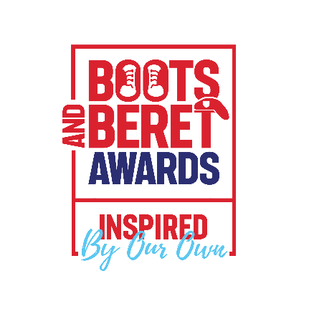


Nottinghamshire County Council Armed Forces Community Awards 2026
We’re excited to announce the Armed Forces Community Awards 2026 – now in our fourth year! These awards celebrate outstanding contributions to the British Armed Forces Community across Nottinghamshire.
The winners will be announced and awards presented at a special award ceremony in September 2026
Who Can Nominate?
Nominations are open to:
- Local authorities and businesses who are signatories of the Armed Forces Covenant or who are in receipt of either the Bronze, Silver, or Gold Defence Employer Recognition Scheme.
- Parish and Town Councils
- Community groups
- Registered charities within Nottinghamshire
This is your opportunity to nominate the colleagues, teams, and partners you think have demonstrated exceptional performance towards defence people issues.
There are eight categories:
- Inspiration Award - this category provides an opportunity to recognise an individual who has inspired and motivated others within the community and recognises those that have gone above and beyond what may usually be expected. Their selfless commitment and dedication have provided a significant contribution in support of the Armed Forces Community in Nottinghamshire and generated a legacy of awareness and inspiration.
The panel will consider that over a five-year period that this person has:
- Worked with and supported, Regular, Reserve Forces, Cadet Instructors and Veterans.
- Tirelessly advocated service improvements for the whole armed forces community
- Enabled changes in service provision to the betterment of the armed forces community
- Forged partnerships, and increased participation to meet the needs of the whole armed forces community
- By example, encouraged others to face challenges and conquer adversity to achieve positive outcomes

- Employer Award - this award presented to a local enterprise that demonstrate excellence in various aspects of the workplace, such as employee experience and support. That significantly contribute to the Armed Forces community and make a positive impact through their work, and providing a wide range of valuable initiatives.

The panel will consider that over an 18-month period the following was achieved:
- Promoting being armed forces-friendly and are open to employing reservists, armed forces veterans, cadet instructors and military spouses/partners
- Strongly encouraging support to defence people issues to partner organisations, suppliers, and customers with tangible results
- Actively encourage and advocate the value of defence people within their business/professional networks and the communities within they operate
- Provided ways for their workforce to come together and demonstrate support for defence people issues

- Employee Award - this award provides an opportunity by an employer to recognise the outstanding contribution of an individual who has added significant value in the workplace by highlighting the merits of the whole armed forces community. This could be an individual in any role and at any level of the organisation.

The panel will consider that over an 18-month period the following was achieved:
- Shown willingness to go above and beyond supporting colleagues from the armed forces community ensuring a sense of place and belonging
- Demonstrated military principles, and experience in business generating a constructive impact recognised by management for their positive effect
- Actively encourage support to defence people issues to partner organisations, suppliers, and customers with tangible results. *Date project started; numbers involved*
- Organised an event that brought the armed forces community and customers together to celebrate defence people issues

- Health and Wellbeing Award – this category recognises the outstanding commitment and contribution to the care and wellbeing of the Armed Forces Community in Nottinghamshire.
The panel will consider that over a two-year period the following was achieved:

- Working with others to develop and prioritise actions to improve health and wellbeing, build resilience and reduce inequalities. This Includes physical activity, healthy eating and weight management, smoking cessation, mental health, sexual health, alcohol, and substance misuse
- Provided direct training either in a community or workplace setting to enhance the understanding of the needs of the armed forces community
- Actively promote their service to the armed forces community
- *Date project/role started; numbers involved*

- Veteran Community Award – this category recognises how individuals, teams and projects have worked to deliver effective approaches to support the sector within the veteran community in Nottinghamshire.
The panel will consider that over a three-year period that the following was achieved:
- Designed and delivered exceptional provision that supports the needs of the veteran community. *Date project started; numbers involved*
- Established working partnership(s) with extraordinary levels of service demonstrated with evidence of strong veteran engagement fitness capacity provision
- Provides individual planning and personal development through careers advice, employment, education, housing, and health
- Acted as a role model and serves as an example for others to follow providing the veteran community with relevant information, advice and guidance.

- Projects and Events Award – this category honours those individuals or teams that have organised a quality project or event that has raised awareness of the Armed Forces Community or celebrates its historical links in Nottinghamshire.

The panel will consider that over a one-year period that the following was achieved:
- Organised a celebration event that brought the armed forces and wider community together. *Date project started; numbers involved*
- Recorded and highlighted significant periods of the armed forces community in Nottinghamshire
- Preserved military items, memorabilia for the benefit of future generations

- Cadet Force Adult Volunteer (CFAV) of the Year Award - this award will be presented to an adult volunteer who has made an outstanding contribution to their MOD sponsored cadet force.
The panel will consider 3 key criteria, and the successful recipient must achieve at least one of them:
- Raising the profile of cadets within the County which contributes to the positive image of and leads to an increase in Cadet and CFAV numbers
- Supporting their fellow peers and cadets’ members of the wider community and contributing to a better society (this can include mental wellbeing and acts of public good)
- Through commitment and dedicated pursuit of excellence in the delivery of an aspect of their syllabus

- Reservist of the Year Award – This award recognises the importance of British Armed Forces Reservists and will be presented to a serving reservist of any rank who has balanced a successful career in business in any role while also dedicating themselves to the commitments required of service within Reserve Forces.
The panel will want to see evidence of:
- The recipient’s success in business and Reserve Force service
- Dedication and commitment to both roles
- Transference of skills – from Reserve service to the workplace, or workplace to the benefit of Defence
- Championing and advocating for service within the Reserve in the workplace or wider community

What does a good nomination look like?
A good nomination should demonstrate the following:
- be people focused.
- be outcome focused.
- making a positive difference
- ambitious standards of practice
- based on evidence
- date project started; numbers involved.
- going the extra mile
- lessons for others

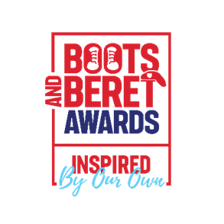Nomination Form
Submitting a nomination
Depending on which category you are submitting a nomination for, the work you are recognising must have been completed within either the last five years, three years or 12 months (up to the closing date for nominations).
Nominations should not exceed more than 500 words and should include tangible results. Nominations can include supporting evidence such as compliments and feedback from colleagues or external partners.
All nominations will be subject to a shortlisting process and a judging panel will decide on the finalists for each category.
Finalists, 3 per category, will be invited to a photographic session for media purposes with the recording(s) being shown during the awards evening. Each successful finalist will receive two free tickets to the event.
Data Protection
We will keep the personal information you give us on this form safe. Your information is protected by law. This means that:
• We will only use it for the purpose we give on the form.
• We only share it with people who need to see it.
• We only keep it for as long as we must;
• You have a right to see the information we hold about you.
Nottinghamshire County Council’s Privacy Statement can be found at: https://www.nottinghamshire.gov.uk/privacy

1. Which category would you like to submit a nomination for? (Select only one)
☐ Inspiration Award
☐ Employer Forces Award
☐ Employee Forces Award
☐ Health and Wellbeing Award
☐ Veteran Community Award
☐ Projects and Events Award
☐ Cadet Force Adult Volunteer (CFAV) of the Year Award
☐ Reservist of the Year Award

2. Name of nominee
________________________________________

3. Your nomination entry - Limit 500 words
(Please type your entry below)

4. Your name
________________________________________

5. Your job title
________________________________________

6. Your Organisation
________________________________________

7. Your Contact Details
Email: ________________________________________
Telephone: _____________________________________

8. Their Contact details – to be used if nominated as a finalist
Email: ________________________________________
Telephone: _____________________________________

Please return the nomination by Friday 2 May 2025 to Bootsandberetnominations@nottscc.gov.uk
Boots and Beret Awards 2025 | Nottinghamshire County Council

